**Concept:**

Payforth is an application designed in conjunction with its parent restaurant Olive Grove, with an aim in allowing its patrons to buy meals for people who are in need of them. This is done in a pay it forward style.

Patrons will able to access the application and select a meal from a set number, before paying for it and allowing the restaurant to process the purchase. The purchase record (receipt) will then be physically printed out along with a QR code on the receipt.

When a person enters the restaurant in need of a meal, they will proceed to a special counter where they can “claim” a meal that has already been paid for. The cashier at the counter will then scan the QR code and log that the meal has been taken, and it will also send a signal back to the application whereby the person who paid for it will be notified that someone took his purchase.

This can be linked to a points system whereby a customer who repeatedly donates food can accumulate points which can then be redeemed for rewards like discounts and free gifts/ food.

**Competitor Analysis:**

Beneficiary side:

Tan Tock Seng Hospital Registration system –

The Tan Tock Seng Hospital uses an IC based registration system to log patients and visitors. The interface used is a touch screen device mounted on a stand that provides a simple set of steps to allow the visitors entry into the wards.

First, the user has to authenticate their identity with their IC by scanning it. They then have to enter the patient’s name and the ward they are currently staying in. A ticket is then printed out for them to use to enter.

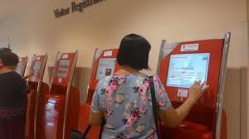

Potential faults in the system come if the user is using someone else’s Identity Card to enter into the system. Because the system cannot authenticate if the user’s IC is indeed his own IC, the system can be cheated.

This system is similar in function to what we intend to do. We however, will be using facial recognition instead to authenticate the user. Facial recognition, while still somewhat rudimentary, is better at authenticating a person’s true identity.

Another option if facial recognition is unable to be implemented is to use fingerprint scanning technology, which is better developed and equally hard to bypass.

And instead of selecting the patient and ward they wish to visit, they may instead select which food item they wish to order. The menu will have to be attached in real time to the restaurant database to make sure the user is aware of what exactly is available at that given time.

The request may then be processed by the restaurant and served to the beneficiary when ready.

Japanese Ramen ordering machine –

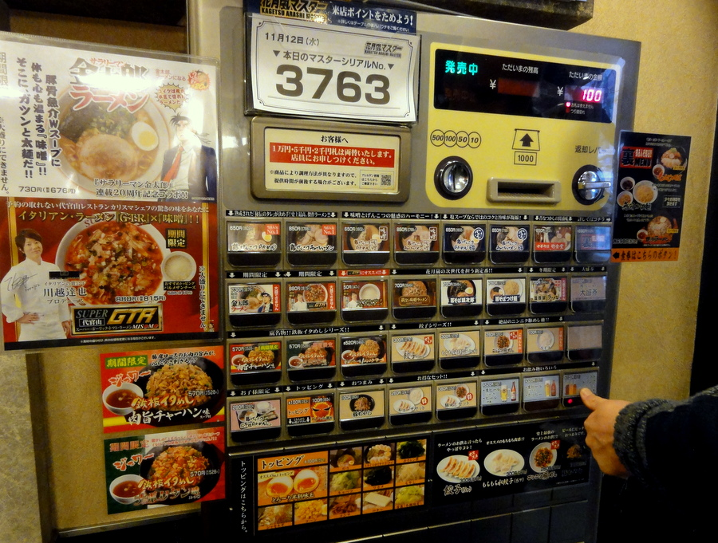

The ramen ordering machines in some Japanese restaurants are made to allow users to order ramen noodles without having anyone at the counter.

The user inserts cash, then presses the button for whichever item they wish to order. A ticket with a number is printed out which the user may then use to collect his meal from a collection counter. This operates much like any other self-ordering kiosk in any other store.

The issue with the design above in particular is the fact that this design requires buttons. For our purposes, the kiosk has to be able to update its available options regularly. Therefore, a touch screen system would be better to display the available items.

Mcdonald’s Self Ordering Kiosk –

The Mcdonald’s self ordering kiosk is an automated means by which customers can order items from the store menu.

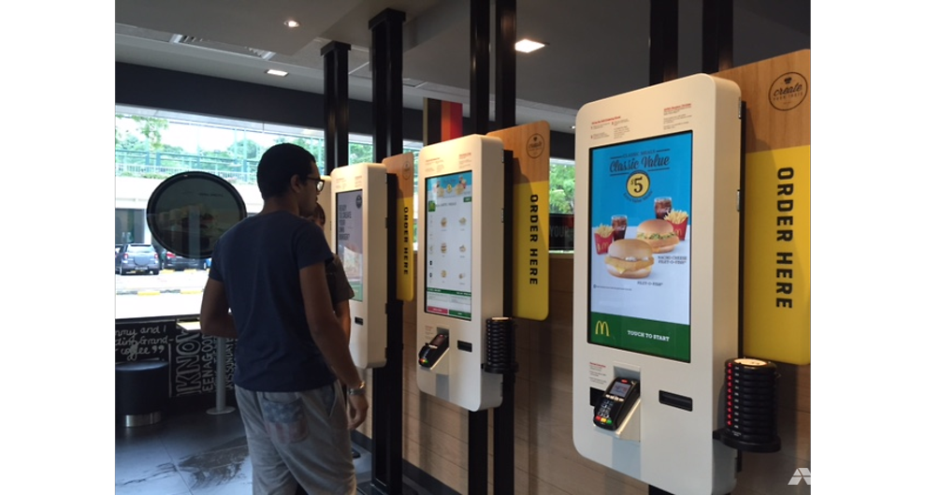

To begin ordering, customers tap on the screen to begin. They may then pick from a variety of categories. If the user picks an item that can be made into a set meal, the machine prompts the user if they want to do so. If they accept, the options for set meals are displayed. The customer then selects their option and moves on to choose their drink. If Café items are available, the user will be given the option to choose drinks from the café. The user is then asked if they wish to add more items like deserts or additional sides before proceeding to payment. A ticket with a number is then printed out and given to the customer to collect their order with.

This whole system is designed to have as many steps as possible to encourage the customer to spend more money and order more food. Therefore it is designed to be as maze-like as possible.

The advantage of this system is that the kiosk can be remotely updated in real time to display available menu items. With just a few button presses, the store can change the availability of an item based on existing stocks.

Our system should use the same real-time updated touch screen system which is used in the SOK. However, the system should have as few steps as possible to streamline the ordering process.

Another advantage of the SOK is the ability to customize the customer’s order. If the customer, for example, wants to remove the sauce on the burger, they can tap on their existing order, then tap on the modify order option. This will take them to a screen where they can add or remove the components that make up that menu item. (eg. No ketchup, pure sauce, extra cheese, plain, etc.)

However, this option is not very well explained. Staff sometimes have to issue guide pamphlets for users to read. (A big no no in DUX). As such, the modification option should be integrated into the ordering process to allow users to remove undesirable ingredients or ingredients which they are allergic to. (No peanuts, no crab, no prawn, etc.)

Design Direction

Basic Sketches